Online Farmer Auction System

Miss. Patil Gayatri Arunkumar Dr.Vaishali P.Vikhe

Department of Computer Engineering Department of Computer Engineering

Pravara Rural Engineering College Pravara Rural Engineering College

Savitribai Phule Pune University Savitribai Phule Pune University

Loni, India Loni, India

gayatripatilgp123@gmail.com mandhare@yahoo.com

ABSTRACT -

**The online farmer auction system is a web-based application that isdeveloped using Java programming language. The purpose of this system isto provide an online platform for farmers to sell their produce to interested buyers. The system provides a user-friendly interface for both farmers and buyers to interact with each other. The system allows farmers to register as admin and list their products for sale. Buyers can also register themselves and search for products that match their requirements. Once a buyer finds a suitable product, they can place a bid on it. Farmers can view the bids and select the highest bidder. The system also provides a feedback mechanism where buyers can rate the products and farmers based on their experience. This helps in building trust among the users and ensures the quality of the products being sold. The online farmer auction system is implemented using Java Servlets and JSPs. The system uses MySQL as the database backend to store user information and product details. The system is deployed on a web server and can be accessed by users from anywhere with an internet connection. Overall, the online farmer auction system provides a simple and efficient way for farmers to sell their produce and for buyers to purchase fresh and quality products directly from the source. An internet-based auction is one that is held online. It is a common way to purchase and sell goods and services. Customers can sell and buy products at the greatest price using an online auction system. It is being created with the intention of making the system dependable, simple, and quick. The objects are sold by price bidding in an online auction, which uses a distinct business strategy. This study focuses on the middlemen’s commissions in the supply chain, which cause significant inflation for consumers. In essence, farmers receive poor payments from the middlemen relative to their investments in the harvesting of the crop. A mobile application for Android will be created to assist village farmers in selling their products directly toconsumers. The goal of this system is to close the gap between farmers and consumers. By doing so, farmers will earn more money, and consumers willbe able to purchase high-quality goods directly from farmers for lower prices.**

Keyword—Admin Module, User Module , Online auction

I . INTRODUCTION

An online farmer auction system is a web-based platform designed to facilitate the buying and selling of agricultural products between farmers and buyers. It provides a virtual marketplace where farmers can list their products, set prices, and negotiate with potential buyers. The system enables farmers to reach a wider audience beyond their local communities and access competitive prices for their products. On the other hand, buyers can search for specific products, compare prices, and purchase products from the comfort of their homes or offices.

The online farmer auction system is built to enhance transparency, efficiency, and trust in agricultural transactions. It eliminates the need for intermediaries, such as brokers or middlemen, who may increase the cost of transactions and reduce the profits for farmers. With the system, farmers have more control over their pricing, and buyers have direct access to the source of their products.

The system also provides a platform for farmers to learn about market trends, consumer preferences, and pricing strategies. It enables farmers to track their sales, monitor customer feedback, and improve their marketing strategies. Additionally, the system provides a secure payment gateway that ensures timely payment to farmers and reduces the risk of payment fraud.

In summary, an online farmer auction system is a revolutionary platform that connects farmers and buyers, enhances transparency, efficiency, and trust in agricultural transactions, and promotes the growth of the agricultural sector.

II. LITERATURE SURVEY –

1. **Paper Name**- Agriculture Marketing Using Web and Mobile Based Technologies

**Author:** Abishek A.G.

**Description:** The goal of this initiative is to ensure that farmers receive fair prices by developing innovative methods and utilising the online market. a programme that acts as a conduit for the delivery of agricultural goods from producers to consumers or retailers. Our mobile and online application gives farmers, customers, and retailers the ability to acquire and sell the necessary farm products at the proper profitable price without the involvement of a middleman. The product that is submitted to this platform will be examined by agriculture specialists, who will then approve it and provide ratings depending on quality. As a result, all farm products are now freely accessible. As a result, it offers both pricing and access independence. By doing this, we can make sure that farmers choose the best possible marketing strategy.

1. **Paper Name**- E-Marketing and Challenges among Indonesian Coffee Farmers

**Author:** Yanty Faradillah

**Description:** In addition to being a significant source of foreign cash, coffee is significant to the Indonesian economy since it creates local jobs and revenue for coffee growers. Up to 70 to 80 percent of the harvest of green beans is exported from Indonesia. Over 2 million small farmers, most of whom reside in isolated communities spread across the archipelago with various coffee-growing regions that exhibit variation in production practises, are responsible for the majority of the world's coffee production. Due to their limited access to extension services, tiny landholdings, inconsistent incomes, and general vulnerability, Indonesian coffee farmers are somewhat at risk. Based on the information gathered, we can say that most of the married coffee farmers in Aceh have been there for 15 to 20 years. owned a coffee plantation with a 1 to 1.49 hectare (ha) area, 1 to 5 employees, and a 19 to 24 harvest cycles per year. They decide to sell to middlemen despite having a net income between Rp 4,100,000 and Rp 7,000,000. Hence, one can draw the conclusion that coffee growers in Aceh are financially sound, but their spending is high due to the high cost of the family, which has an average of five children. Help is therefore required to enhance their revenue once more. Farmers are constrained by the pricing (34.3%), location (25.6%), products (16.9%), buyer (9.8%), and promotion (0.9%) when it comes to selling coffee.

1. **Paper Name**- AGRITECHNO: A Development of a Revolutionized Farmer Assisted Agricultural Product Forecasting Mobile App System

**Author:** Joe Marie D. Dormido

**Description:** The Philippines' agriculture industry plays a significant role in the country's economic growth. It contributes to the community's agriculture product supply and is a significant source of employment in rural areas. Yet recently, farmers have been having issues with low prices for locally produced commodities due to heavy importation from Asian neighbours. The majority of farmers are members of the community's fringe, and they occasionally receive less attention from the government. Hence, as the population grows, so does the demand for food goods. Another factor that affects the amount of food consumers consume on a daily basis is their way of life and level of awareness. Farmers can meet with traders to sell their goods in the local market, which is typically found in trading post regions. This creates a potential market for domestic consumption to receive higher-quality farm products than are now produced.

The creation of Agricultural Technology of Negros Occidental (AgriTechNo), a system for anticipating agricultural product prices that is monitored in the trading post, aids farmers in choosing where to sell their goods and determining the market value of those products.

1. **Paper Name**- Agricultural Year-Round Planning Model for Market-oriented Farms

**Author:** J. Chaiwongsai, N. Boonthep, Y. Miyanaga , T. Cheosuwan, B. Innawong

**Description:** Farmers now struggle with the cost of their agricultural products because tradespeople provide low prices and produce plants without considering the market's demands. Certain products are thus in short supply or overproduction. Also, the majority of farmers lack the market-appropriate processing competence. Hence, to boost the farm's potential for the market competition, agricultural year-round planning should be set up in accordance with market demands. The model for agricultural year-round planning that is suggested in this research examines agricultural inputs for year-round planning and farmer skills according to plant types based on market demands. You can use a web application to access the model. 5 farmer union leaders from various regions and 2 agriculture entrepreneurs tried and assessed it. The assessed results demonstrate that the model is capable of accurately predicting the outcomes of year-round planning as well as farmer capabilities, areas, and quantity. The average satisfaction rating from 7 users is 4.46.

1. **Paper Name**- E-Mandi Implementation Based On Gale-Shapely Algorithm for Perishable Goods Supply Chain

**Author:** S.Prasanna Devi, Y.Narahari, N.Viswanadham, S.Vinu Kiran, S.Manivannan

**Description:** We suggest in this study that the traditional agricultural trading between farmers and customers in the agricultural supply chain be converted into an electronic exchange. Mathematically modelled preferential assessments of customer and supplier satisfaction are used to create a preference matrix that is fed into the Gale Shapely matching algorithm. In a bilateral e-trading context, the outcomes of m*n matching happen to be a fairly clear technique. These outcomes are contrasted with those attained by the Pareto-optimal matchmaking process of the simple English auction approach. The proposed method is found to yield stable matching that is preference-strategy proof and also lessens the number of allocation rounds required.

III.PROPOSED METHODOLOGY:

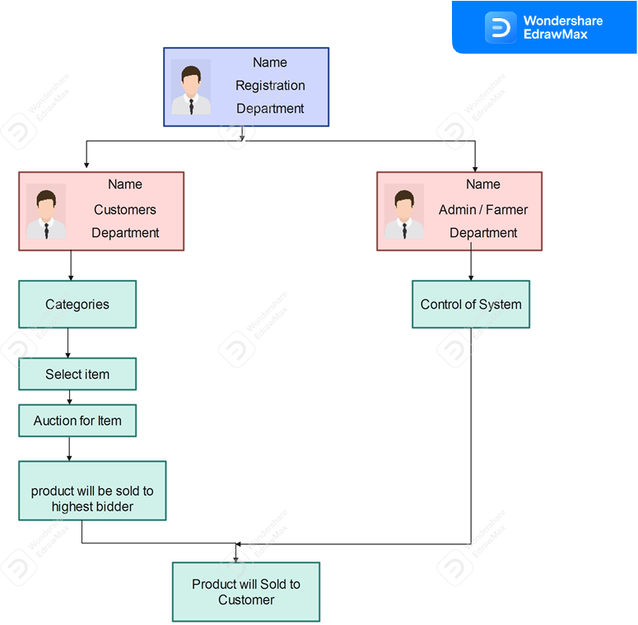

Figure : System Architecture

1. SYSTEM ARCHITECTURE

The online farmer auction system is a web-based application that aims to connect farmers with buyers through an online bidding platform. The system architecture for this project involves several components that work together to provide a seamless user experience.

At the core of the system is the database that stores information about the farmers, their products, and the bidding history. The database is implemented using MySQL, a popular relational database management system, and is accessed through Java Database Connectivity (JDBC) API. The application logic is implemented in Java, and it runs on a web server such as Apache Tomcat. The Java code communicates with the database using JDBC to retrieve and update data. It also handles user authentication and session management to ensure secure access to the system. The front-end of the system is implemented using HTML, CSS, and JavaScript. The user interface is designed to be user-friendly and responsive to different screen sizes. The front-end communicates with the back-end using AJAX to update the page dynamically without requiring a page refresh.

Overall, the system architecture for the online farmer auction system project involves a combination of Java, MySQL, HTML, CSS, JavaScript to provide a robust and scalable platform for farmers and buyers to connect and trade agricultural products.

1. ALGORITHM : Bidding Algorithm for the First Price Sealed Bid Auction

* procedure Start
* Determine the items being auctioned and the starting price.
* Specify the bidding rules and the deadline for bids.
* Invite potential bidders to participate and provide them with the relevant information, such as the starting price, bidding rules, and deadline.
* Bidders submit their sealed bids before the deadline.
* The auctioneer opens all bids simultaneously at the deadline.
* The highest bidder wins the auction and pays the amount they bid.
* The auction ends, and the item is transferred to the winning bidder.

The mathematical equation for the First Price Sealed Bid (FPSB) auction can be expressed as follows:

* Bidder i’s expected payoff = (Pr(i wins) * (Vi - Bi))

Where ,

* Pr(i wins) is the probability that bidder i wins the auction, which can be calculated using the bid distribution of all bidders and the auction rules.
* Vi is the value of the item to bidder i.
* Bi is the amount that bidder i bids. In the FPSB auction, the highest bidder wins, so the probability that bidder i wins is equal to the probability that their bid is the highest among all bidders. The bidder’s expected payoff is calculated as the difference between the value of the item to them and the amount they bid, weighted by the probability that

they win.

* end procedure

IV.CONCLUSION AND FUTURE WORK

The online farmer auction system is a promising platform that can revolutionize the way agricultural products are bought and sold. The system provides a digital marketplace for farmers to auction their produce and allows buyers to bid on the products they require. By adopting this platform, farmers can sell their products directly to buyers without the need for intermediaries, thereby increasing their profits. The online farmer auction system is highly beneficial to both farmers and buyers as it provides a transparent and fair bidding process, eliminating the possibility of price manipulation. It also offers convenience and flexibility as buyers can purchase products from anywhere at any time. Moreover, the system can help to address the problem of food waste by enabling farmers to sell their entire harvest, including the imperfect or surplus produce, which may have been discarded earlier. Additionally, it can promote sustainable agriculture by encouraging farmers to diversify their crops and reduce monoculture. In conclusion, the online farmer auction system has immense potential to transform the agricultural industry by providing an efficient, transparent, and convenient platform for buying and selling produce. It can benefit farmers, buyers, and the environment, making it a valuable addition to the agricultural ecosystem.

FUTURE WORK

An online farmer auction system has the potential to revolutionize the way farmers sell their produce and connect with buyers. The system can provide a platform where farmers can list their products and buyers can bid on them, resulting in fair pricing for both parties. In the future, the online farmer auction system can be expanded to include features such as real-time bidding, advanced search options, and an integrated payment gateway. The system can also incorporate AI-based algorithms that can analyze market trends and suggest optimal pricing strategies for farmers. Furthermore, the system can be scaled up to accommodate more farmers and buyers, resulting in increased market access for farmers and a wider variety of products for buyers. The online farmer auction system can also provide farmers with valuable data on market trends, demand, and pricing, allowing them to make informed decisions about their produce. In addition, the system can be integrated with logistics and transportation services, streamlining the delivery of products from farmers to buyers. This can further enhance the efficiency of the system and reduce transportation costs for farmers.Overall, the future scope for an online farmer auction system is vast, with the potential to transform the agricultural sector and provide numerous benefits to farmers and buyers alike.

REFERENCES

1. Majadi N, Trevathan J and Bergmann N. uAuction: Analysis, Design, and Implementation of a Secure Online Auction System. In Dependable, Autonomic and Secure Computing, 14th Intl Conf on Pervasive Intelligence and Computing, 2nd Intl Conf on Big Data Intelligence and Computing and Cyber Science and Technology Congress (DASC/PiCom/DataCom/ CyberSciTech), 2016 IEEE 14th Intl C, pp. 278- 285.
2. Hillston J and Kloul L. Performance investigation of an on[U+2010]line auction system. Concurrency and Computation: Practice and Experience, 2001, 13(1): 23-41.
3. Darryl Jeethesh Dsouza, H.G.Joshi, “Development of agricultural ecommerce framework for India, a strategic approach,” International Journal of Engineering Research and Applications (IJERA) [www.ijera.com](http://www.ijera.com), ISSN: 2248- 9622, Volume 4, Issue 11 (Version - 5), November 2014, pp.135-138.
4. Bajari, Patrick, Ali Hortacsu (2004). ”Economic Insights from Internet Auctions” Journal of Economic Literature, Vol. XLII No. 2: 457-86. [5] Lucking-Reiley, David (2000), “Auctions on the Internet: What’s Being Auctioned, and How?”Journal of Industrial Economics, 48(3): 227–52.
5. Milgrom, Paul R. and Robert J. Weber (1982), “A Theory of Auctions and Competitive Bidding,” Econometrica, 50(5): 1089–1122.
6. S Subramanian 1998 “Design and verification of secure electronic auction” proceedings of IEEE Symposium on reliable distributed system.
7. Sandeep Kumar, “Pricing Algorithms in Online Auctions,” Computer Engineering Department, UIET, M.D.UniversityRohtak, Haryana, India
8. Kaleesari,Noble Mary Juliet “Dynamic Resource Allocation by using Elastic Compute Cloud Service” , International journal of Innovative Research in Science Engineering and Technology, vol.3, pp. 1237-12379,
9. 2014.
10. Dinesh Satpute1 , Mayuri Bhoyar2 , Amit Kumar Pandey3 , Prof. Ms. Tinal Thombare4, “Research Challenges in Online Auction”, International Journal of Research in Advent Technology Vol:5, No.2, Feb 2017
11. R.L. Meena1*, B. Jirli1 , M. Kanwat2 and N.K. Meena3, “Mobile Applications for Agriculture and Allied Sector”, International Journal of Current Microbiology and Applied Sciences Vol: 7 No.2, (2018)
12. Ms. Monika K. Hande1 , Ms. Sayali A. Navale2 , Ms. Arati D. Jadhav3 , Ms. Prabhavati P. Khutal, Prof.Mr.Y.S.Gunjal,” Network of Agricultural Commodities for Farmer’s Benefit”, International Journal of Advance Engineering and Research Development, Vol: 5, Issue:4, Feb- 2018
13. Sindhu M R, Aditya Pabshettiwar, Ketan.K.Ghumatkar, Pravin.H.Budhehalkar, Paresh.V.Jaju, ” E-FARMING”, International Journal of Computer Science and Information Technologies, Vol. 3 (2) , 2012
14. Hemant Khandelwal1 , Milind Hanchate2 , Ameya Rathod3, “Online Bidding Android Application”, International Journal for Research in Engineering Application amp; Management, Vol-01, Issue 04, July 2015